VISTA

Patch Module 2.5
User Manual: Patch Subscribers
September 2014
prepared for



by

©Copyright 2014 by VISTA Expertise Network. Licensed under Creative Commons Attribution-ShareAlike 4.0 International. Details are available at http://creativecommons.org/licenses/by-sa/4.0/
Revision History
Date | Description | Language | Authors
September 2014 | OSEHRA Version 2.5 release | English (US) | Kathy Ice and Frederick D.S. Marshall

Contents
Orientation 1
Introduction 2
Chapter 1: Patching Then and Now 3
The Old Process 3
The New Process 3
What This Means 4
Chapter 2: Receiving Patches 5
Subscribing to a Patch Stream 5
When the Patch Arrives 6
Installation Using Host Files 7
Chapter 3: Troubleshooting 8
Not Receiving Patches 8
Checksum Doesn’t Match 8
But We Don’t Want That Patch! 10
Backing Out a Patch 10
Appendix A: The Lineage of VistA 13
Glossary 14

Orientation
This manual is one of four user manuals for version 2.5 of the Patch Module. There is a different user manual for each essential role associated with the Patch Module; this manual is for patch subscribers.
If you are the the person at your site in charge of keeping your VistA system patched and up-to-date, you are a patch subscriber.
Patch developers and verifiers have their own Patch Module user manuals,which can be found at www.osehra.org along with the rest of the Patch Module documentation suite.
The Patch Module documentation suite:
Release Notes
Value Proposition
Installation Guide
User Manual: Primary Developers
User Manual: Secondary Developers
User Manual: Verifiers
User Manual: Patch Subscribers
Technical Manual
Security and Privacy Manual

Introduction
The Patch Module, as the name implies, is a software package that allows users and developers to create, revise, distribute, review, and receive software patches and updates for VistA. Options are provided for systematic entry, revision, and review of patches by developers, review and release of patches by verifiers, and display and distribution of the released patches to the users.
But before we get to talking about all the things we can do with patches, it’s probably best to take a moment and make sure we’re all on the same page about what a patch is, and what it does. Patches began as a way of fixing problems in an active VistA system, and many patches released today are simple bug fixes. However, most patches include more than fixes. Developers found that patches were the easiest way to add the enhancements and new features that their users wanted without taking the system offline or releasing a new version. Today, patches are the primary method for making updates and improvements to VistA.
A patch, then, can include bug fixes, upgrades, enhancements, new features, or all of the above. Its main feature is that it can be installed on an active, running VistA system with minimal disruption.
Patches are created in KIDS (the Kernel Installation and Distribution System), but are packaged and distributed via the Patch Module. Until relatively recently, only the developers at the Department of Veterans Affairs (VA) had access to the Patch Module. With this release, the Patch Module becomes more widely available, and more developers have the opportunity to create and release patches.

Chapter 1: Patching Then and Now
With the release of version 2.5 of the Patch Module, the process of patching has undergone some important changes. To understand these changes, and how they might affect how you receive and install patches, we should first look at how patching has been done until now.

The Old Process
VistA was first developed at the Department of Veterans Affairs (VA), and traditionally all changes and enhancements were initiated by national VA developers. They bundled their changes into patches and released them as part of the patch stream, for installation by individual VA sites.
Non-VA organizations running VistA could also subscribe to VA’s patch stream, but VA patches weren’t always compatible with non-VA VistA systems. Developers in these other organizations would have to take the VA-issued patch, make the necessary changes to make it work on their systems, and re-issue the patch to their customers. This was a labor-intensive process, and often involved developers in different organizations doing essentially the same work, without the ability to pool their efforts or share their results with one another.
And, under the old process, the patch stream was one-way. VA initiated patches, and other organizations reacted. There wasn’t a way for the other organizations to issue patches to which VA could react.

The New Process
One of the important recent changes to the patching process was setting up a VistA forum system through OSEHRA. The forum system provides a way for developers to send and receive patches. Previously, VA had the only forum system available, and anybody outside VA did not have access to it. Now that OSEHRA has its own forum, non-VA developers finally have a way to pool their resources and share their efforts.
In addition, parts of the process for converting a VA patch for non-VA use have been automated, so the process is less labor-intensive than it was.
Also, the establishment of a full forum system outside VA means that the patch process no longer needs to be one-way. For the foreseeable future, VA will continue to initiate most patches, but some patches will begin outside VA, as other organizations make improvements and fix bugs.

What This Means
So, what do all these changes mean for you, the patch subscriber? Probably the most obvious change is that you now have a choice of which patch stream to subscribe to. If you are inside VA, or using a VistA system that closely resembles VA, you should subscribe to VA’s patch stream. However, if your VistA system was created and installed by a non-VA organization, including IHS, Medsphere, DSS, or WorldVistA, you probably want to subscribe to the OSEHRA patch stream instead.
The OSEHRA patch stream distributes patches for OSEHRA VistA. If your VistA system is supported by another organization, it might not be compatible with OSEHRA VistA, any more than it is compatible with VA VistA. The VistA organizations are working diligently toward “code convergence,” meaning that one day, most VistA code will be interchangeable, and everybody can use the same patch stream. However, we are not there yet. For that reason, your organization may choose a different method for distributing and installing patches. If you are unsure whether you should be subscribing to the OSEHRA patch stream, discuss the issue with your VistA vendor.

Chapter 2: Receiving Patches
Before OSEHRA forum was set up, the only way for non-VA sites to receive patches was to download files from an FTP site. This was a time-consuming, labor-intensive process. The developer in charge of patching would have to go to the site, look at the patches, and try to figure out which ones were the most recent, and whether they had already been installed. This was not always easy to determine.
With OSEHRA forum, sites can subscribe to patch streams, meaning that new patches are sent directly to the site for immediate installation, the way they are inside VA. In this chapter, we describe how to subscribe to a patch stream, and what to do with new patches when they arrive.

Subscribing to a Patch Stream
Forum sends patches as Mailman messages. So, in order to subscribe to a patch stream, you first need to ensure that your site’s Mailman is configured to receive network mail—that is, mail from outside your facility. Information on how to configure Mailman can be found in the Mailman documentation suite. You will probably need to enlist the help of your site’s system manager and network manager to get Mailman properly configured.
Next, you need to decide where you want the patches emailed—that is, which email address will actually be subscribed to the patch stream. It should probably be an account that goes to a development or test environment, and not your production environment. Many sites set up a “Patches” mail group, and subscribe the group to the patch stream, rather than an individual email address. If you do it this way, then everyone in the mail group will receive a copy of the patch. This also means that if one of your developers quits or leaves, you only need to update the mail group, rather than re-subscribing to the patch stream.
Next, you need to install XU*8.0*999. You can do this by downloading the host files from www.osehra.org, or you can ask a developer at another site to send the patch to you via email. Install the patch using KIDS. Once the installation is complete, you will be given the opportunity to subscribe to either the OSEHRA patch stream, or the FOIA (VA) patch stream.
If you are already subscribed to a patch stream, you will be given an opportunity to change your subscription from FOIA to OSEHRA.
To ensure system integrity, each site is only permitted to make this switch once. Once you have selected a patch stream, your site will be subscribed to that stream for the foreseeable future.

When the Patch Arrives
If you are subscribed to a patch stream, your patches will be emailed to you. You can open your emailed patch in whichever email client you choose.
However, we recommend using Mailman to open emailed patches, because Mailman, through its Packman feature, is designed to work with KIDS. If you open your patch email from your Mailman in-basket, one of the options you will see is to launch Packman. Once Packman has been launched, one of its options is to load a distribution. Select this option, and your patch will automatically be loaded into KIDS.
Packman takes care of the code, but you will probably also want the text and descriptions that were emailed along with it. Save the original email to retain this information, or edit out the code and just save the text. You can save it in an email folder or in a text file; the important thing is to choose one method consistently and remember where you saved the information.
With your description saved and your patch code loaded into KIDS, the next step is to install the patch. Be sure to install it in a development or test environment before attempting to install it in your production environment. For information on using KIDS to install a patch, please refer to the Kernel documentation suite.

Installation Using Host Files
Although receiving a patch stream via email is more convenient and efficient than manually searching for files at a site, you do still have the option of finding and installing host files on your own. Host files for all OSEHRA VistA patches are available through the OSEHRA repository at www.osehra.org.

Chapter 3: Troubleshooting
Into every life a few glitches must fall. In this chapter, we address ways to deal with some of the problems you may encounter, including a couple of examples of what not to do.

Not Receiving Patches
If you realize that you haven’t received any new patches for a while....there may be nothing wrong. In VistA’s heyday, new patches for one package or another could be expected just about every week. Now, patches are not issued that frequently. So, if you haven’t received any new patches for a while, it may just be that no new patches have been issued for a while.
However, if you know there are patches you did not receive, you should check to be sure you are still subscribed to the appropriate patch stream. If your site is subscribed as a mail group, check to be sure the appropriate people are members of the mail group. Once you have corrected any subscription mistakes, you can get any patches you may have missed by downloading the host files from www.osehra.org.

Checksum Doesn’t Match
One of the first steps in the installation process is to have KIDS automatically calculate the checksum of the affected routines, and compare it with the checksum that is expected by the patch. If the checksums are different, KIDS alerts you.
What could cause the checksums to be different? One possibility is that you missed a patch somewhere along the line, and your system is not as up-to-date as it needs to be. Check your patch logs, and talk to any other developers in charge of patching, to see if this is the case. If you do find that a patch needs to be installed, install it and try again.
Another possibility is that your site has some local modifications in the affected routines, which have changed the checksums. Your facility should keep a record of local mods; check it to see if any of them could be affecting the checksum. You may also want to talk to any developers who may have been working on the affected routines.
Local mods are name- and numberspaced, so it’s very possible that you can install the new patch and everything will continue to work fine. It’s also possible that the new patch may overwrite some of the changes your local developers made; if this is the case, they will have to be restored once the patch has been installed successfully. Either way, if you know that the difference in checksum is caused by a local mod, you can tell KIDS to proceed with the installation anyway, even though the checksums do not match.

A Word About Local Modifications
Local modifications make some developers and managers very, very unhappy. They see local mods as a deviation from the standard, and therefore something to be avoided.
Actually, VistA was designed to be customizable at the local level. Local mods are not a departure from the standard; they are an expression of the standard. Local mods are needed because medicine is not practiced the same way everywhere, and when the medicine and the software don’t agree, the medicine should win. Every time.
Your local modifications, then, are what enable your clinicians to practice medicine the way they think is best. You need your local mods—even if it occasionally means that installing a patch requires a few extra steps.

Checksums Don’t Tell You Everything
Checksums are a wonderful tool, but they don’t tell you everything. This is because they only apply to any routines included in the patch. Patches, however, can encompass much more than just routines; they can also include options, protocols, templates, and more. If you are installing a patch that includes more than just routines, the checksum comparison isn’t going to tell you the whole story. It might, for example, say that your system is fine and ready to be patched, when really you have local modifications in a couple of options that are about to be overwritten.
This is why, when you install patches, you have the opportunity to print the patch (the “transport global”), and to compare the patch to the current system. These steps enable you to manually check for changes that the checksum comparison didn’t catch.

But We Don’t Want That Patch!
VistA has a Dentistry package, but most non-VA sites running VistA don’t use it. Many of the sites simply don’t have a dental clinic and therefore don’t need it; many other sites have decided to use commercial dental EHRs instead of VistA.
If you are one of those sites, then what do you do when a patch comes out for the Dentistry package? Or, for that matter, what do you do when a patch comes out for any package you are not using? Is there a way to unsubscribe to these packages?
There may be a way to customize your patch stream subscription in the future, but really there’s no need. If a patch shows up in your email, and it isn’t one your facility is especially keen to install, just don’t install it. After all, there’s no Patch Police that’s going to come around and cite you for Failure to Patch. Just delete the email (or better yet, save it somewhere just in case), and go on with your day.
You probably want to check the patch over first, just to be on the safe side. After all, a patch that primarily affects the Dentistry package may also include a couple of changes to Fileman, or Kernel, designed to support the changes to Dentistry—and you may want those. In most cases, though, you can safely ignore patches for packages your facility is not using.

Backing Out a Patch
VistA patches are thoroughly tested before they are sent out. It does occasionally happen, however, that a patch gets installed and causes numerous errors in the system. If this ever happens, developers quickly begin looking for a way to back out the changes. Sometimes this is possible, and sometimes it isn’t.
As an illustration, if you accidentally drop your wedding ring into your coffee, it’s a pretty easy fix. You just fish it out again, and everything’s fine. On the other hand, if you accidentally put salt in your coffee, thinking it’s sugar, that’s not an easy fix. The salt has already dissolved; there’s no recovering it. So unless you can convince yourself that it’s really a Salted Caramel Macchiato, you’re probably going to need to start over.
Some VistA patches are “wedding ring in the coffee” patches. They’re pretty straightforward changes to routines, easily recognized and easily reversed. One of the steps in your patch installation process is to make a backup copy of any affected routines. If the patch begins to cause problems, it’s an easy fix to restore the routines from backup.
But some VistA patches are more “salt in the coffee.” They are designed to spread changes throughout VistA—often, by making changes that in turn trigger other changes. Chasing all of these down, and backing them out, is impossible given VistA’s massive scale. In a case like this, your best option is to restore the system using a system backup.
Of course, you do have backups of your system, right? And of course, you installed that patch in a development or test environment, right? As we said at the beginning of the section, patches are thoroughly tested, but that doesn’t mean that nothing ever goes wrong. Always install patches in a development or test environment to ensure they work properly, before installing them in your production environment.

A Fresh Install of VistA
Developers and managers familiar with other kinds of software may be tempted, at some point, to want to do a fresh install of their VistA system. After all, this patching and fixing can’t be good for the software! Why not start afresh by installing a clean copy and going from there?
That funny leaking noise you hear is all the experienced VistA developers trying to breathe, because we just gave them a nasty shock. VistA isn’t like other software, and overwriting your current system with a “clean” copy is not a good idea.
There are a few reasons for this, but the most important one is that VistA, internally, does not distinguish between code and data. All of your facility’s patient data is intertwined with the code of your VistA system. If you overwrite that system with a new one, all the data in the database will also be overwritten. And we don’t have to tell you what a mess that would make.
The only time a “clean” copy of a VistA installation is used is when setting up a brand-new instance of VistA for a hospital or clinic that is using VistA for the first time.

Appendix A: The Lineage of VistA
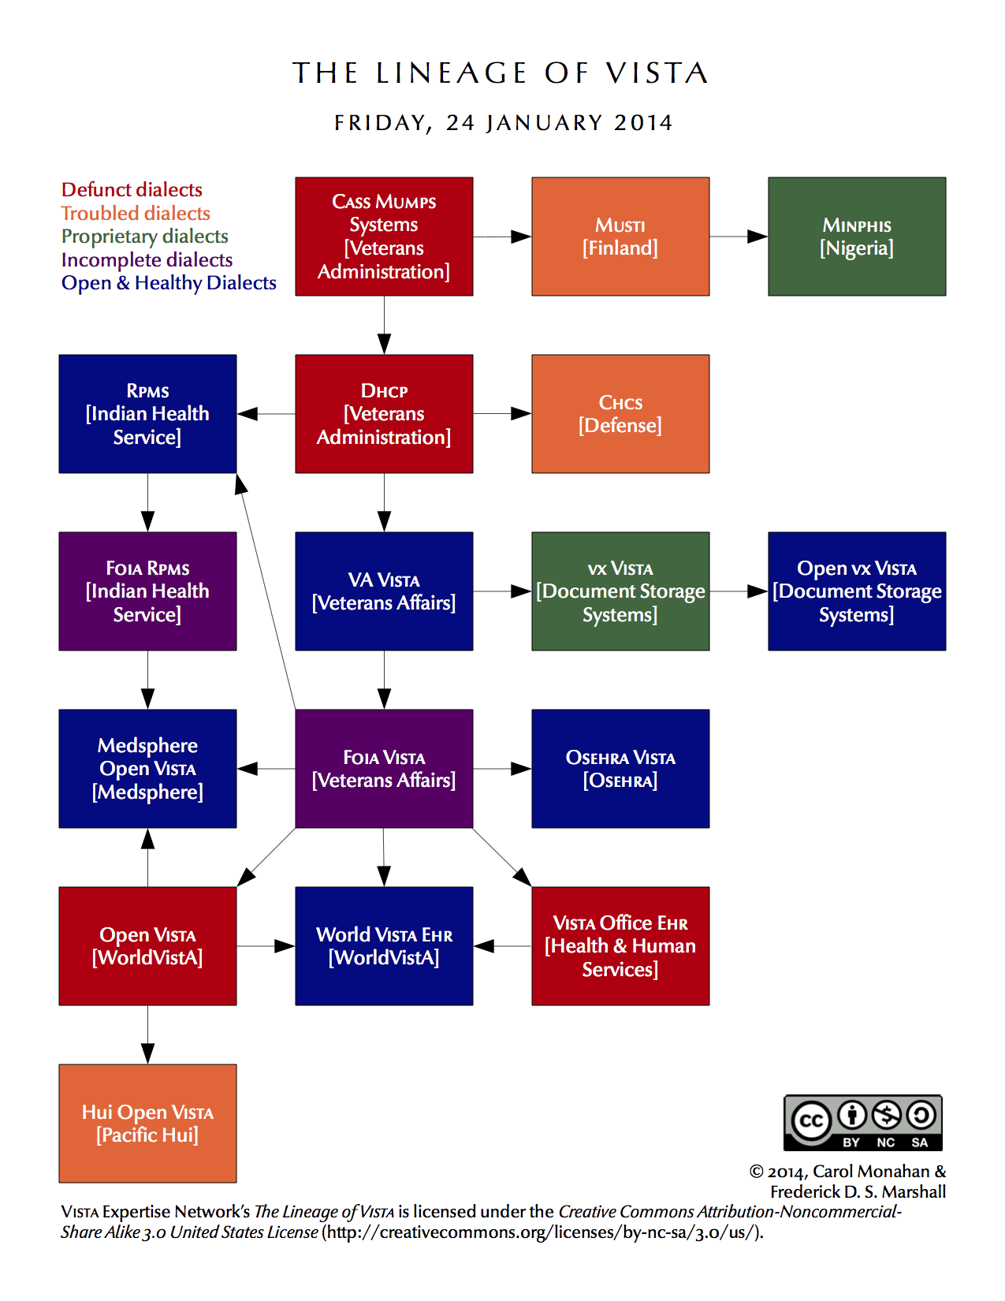

Glossary
Application An administrative division of VistA that automates part or all of one hospital or clinical service. Pharmacy and Nursing are examples of applications.
Application Version A complete new release of an application. Versions are numbered sequentially.
Build See KIDS Build
Checksum A number unique to any given version of a software element. Even a small change to the software will change the checksum, so checksums are used to detect changes and verify a particular version.
Dialect See VistA Dialect
Distribution See KIDS Distribution
FOIA Freedom of Information Act. The term “FOIA” can refer to the Act itself, or to a request sent to the government under the auspices of the Act.
Forum A VistA system used as the hub of an organization’s VistA software lifecycle. VA and OSEHRA each have their own Forums.
Gerrit A code-review system for use with a repository such as Github.
Git A version-control system.
Github A platform that hosts repositories using the Git system.
Host-File Format A file-based format for a KIDS distribution. It consists of two parts: the KIDS file and the text file.
KIDS The Kernel Installation and Distribution System. KIDS is the primary method for preparing a patch for the Patch Module, as well as the mechanism for installing patches.
KIDS Build The “manifest” of a KIDS distribution, which lists all the components included in the distribution.
KIDS Distribution A host file or Packman message containing a software update and associated tools and conversions for applying it.
KIDS File In a host-file format, the portion of the file containing the software.
KIDS Install A record describing what happened during each installation of a KIDS distribution at a specific site.
Local Modification A change to VistA made for a specific facility or organization. Local modifications are necessary in VistA, but result in changes to checksums that make version control more challenging.
Mailman VistA’s native email system. Patches can be distributed using Mailman’s Packman module.
Namespace A convention for naming VistA package elements. Each developer or organization is assigned a namespace, which is a unique character string, to be used use in naming routines, options, and other package elements. Namespacing helps keep similar elements from different developers distinct and easily identifiable.
Numberspace Similar to a namespace, a numberspace is a unique numeric string assigned to a developer or organization. Numberspaces are used for VistA elements that have numbers rather than names.
Package A distribution of a new version of an application.
Packman A module of Mailman used to ship patches and other software.
Packman Format A format for a KIDS distribution designed for use with Packman.
Packman Message Any email message that contains a KIDS distribution in Packman format.
Patch Any small change or update intended for installation in an active VistA system. Most patches can be installed with minimal disruption to the system or its users.
Patch Completer The developer who reviews the patch developer’s work, then updates the status of the patch in the Patch Module to “completed.”
Patch Developer Person who initially entered the information on the patch into the Patch Module. That person will be listed as the “developer” in the Patch Module, whether they did any actual development work or not.
Patch ID A multi-part identification number for a patch, which includes the application namespace, the application version number, and the patch number.
Patch Message An email message that contains a patch description and a Packman-format KIDS distribution. This is the default method for the Patch Module to distribute patches.
Patch Number Unique number given to a patch, as it relates to the specific application and version. Patch numbers are numberspaced, so patches from different sources can be immediately distinguished.
Patch Reviewer In secondary development, the developer who reviews the released patch to determine what kind of secondary development might be needed.
Patch Stream The series of patches developed and released for a specific application or dialect.
Patch Subscriber A person or organization who has signed up to receive a particular patch stream.
Patch Verifier Specialist who confirms that the patch is functionally complete, and meets all standards. Verifiers make the decision to release the patch.
Primary Developer The person or team who initiates the patching process and releases a new patch.
Primary Development The actions involved in creating and distributing a new patch.
Repository Online electronic storage which houses reference versions of a specific software. Generally, one version is designated as the “official” version. OSEHRA provides repositories for OSEHRA VistA and FOIA VistA.
Required Patch A prerequisite patch. All patches should list their required patches—that is, their prerequisites—for installation.
Secondary Developer The person or team who re-purposes a released patch for their VistA dialect.
Secondary Development The actions involved in re-purposing a patch for a different VistA dialect.
Sequence Number Unique number assigned when a patch is verified. It determines the default order in which patches should be installed.
Text File In host-file format, the portion of the file that contains the patch description.
Version See Application Version
Version Control A system or methodology for ensuring that all software within a given organization is the same version.
Version Number The sequential number of the current application version. Each VistA application has its own version number. For example, the current version of Laboratory is 5.2, while the current version of Fileman is 22.2.
VistA Dialect A unique, stable version of VistA supported by a specific vendor. Popular VistA dialects include OSEHRA VistA, vxVistA (Document Storage Systems), Medsphere Open VistAand WorldVistA EHR.
VistA Service Pack A bundle of VistA packages and patches, which can be used to upgrade an existing VistA system.
VistA Snapshot A copy of an existing VistA system. A VistA snapshot is most commonly used to clone a new VistA instance.

